

Product Management Essentials course

Product Idea Workbook

By Shriya Sanjay Sansare

Table of Contents

Product Management Essentials I
Product Narrative 3
1. Customer Problem Space 4
2. Market Space 5
3. Solution Space 6
4. Customer Value Space 7
Appendix 8

Product Narrative

The Problem
The restaurant industry thrives on customer satisfaction and loyalty, yet most restaurants struggle to retain diners in an increasingly competitive market. Diner repeat rates are 40% lower than the industry target of 70%, leading to a $70.51 billion annual revenue loss across 100,000 restaurants.
The key challenges that contribute to this problem include:
- Lack of personalization in dining experiences – Customers want tailored meals based on their preferences but often receive generic offerings.
- Inefficient menu optimization – Chefs rely on intuition rather than data, leading to inconsistent quality and missed opportunities for improved customer retention.
- Limited insights on diner preferences – Restaurants collect diner feedback but fail to translate it into actionable menu enhancements.
- High operational strain on chefs – Managing personalized experiences manually increases kitchen workload and complexity.
Without a data-driven approach, restaurants struggle to retain customers, reducing repeat visits, lowering revenue, and increasing the cost of acquiring new diners.

The Solution: DineIQ

DineIQ is an AI-powered culinary assistant that personalizes meal recommendations, optimizes menu offerings, and enhances diner engagement.
Unlike generic AI-powered kitchen assistants that automate cooking, DineIQ empowers chefs with data-driven insights on diner preferences, past orders, and real-time feedback, allowing them to craft tailored dining experiences while maintaining full creative control.
How It Works
1️. DineIQ syncs with the restaurant’s POS and reservation system to access diner history, preferences, and feedback.
2️. AI suggests dish modifications based on past customer interactions (e.g., “Reduce spice level based on previous orders”).
3️. Chefs receive real-time recommendations in their dashboard and decide whether to apply or modify AI-generated suggestions.
4️. As dishes are served, diner feedback is automatically collected through in-app prompts, loyalty programs, and digital reviews.
5️. DineIQ continuously refines future recommendations using AI, leading to improved personalization and higher customer retention.
DineIQ does not replace chefs, it enhances their creativity and efficiency, ensuring that every meal is tailored to maximize diner satisfaction.

Market Opportunity

The restaurant industry is experiencing a major shift toward data-driven decision-making, yet most restaurants lack the tools to harness diner insights effectively.
Total Addressable Market (TAM):
- 8 million full-service restaurants worldwide could benefit from AI-driven meal personalization.
- Estimated TAM: $22.5 billion annually based on an average $234/month subscription per restaurant.

Serviceable Addressable Market (SAM):
- 1.6 million restaurants (20% of TAM) expected to adopt AI meal personalization in the next 5 years.
- Estimated SAM: $4.5 billion annually.
With the rise of AI in the hospitality industry, DineIQ is uniquely positioned to capture a significant share of this growing market.

Competitive Advantage

DineIQ bridges the gap between AI-driven insights and chef creativity, enabling personalized dining experienceswithout compromising chef control. Unlike traditional POS systems, which lack personalization, and AI-powered kitchen assistants, which focus on automation, DineIQ enhances rather than replaces chef decision-making.
By integrating with POS systems, reservation platforms, and diner feedback channels, DineIQ provides real-time, actionable recommendations that chefs can adapt instantly. Its self-learning AI continuously improves, refining meal personalization to boost diner retention and restaurant loyalty.

DineIQ Advantage : It combines AI personalization, real-time insights, and chef-driven control, positioning itself as the go-to solution for modern, experience-focused restaurants.

Pricing

DineIQ follows a scalable subscription-based pricing model, ensuring affordability for small restaurants while offering advanced AI-driven features for larger chains. The pricing structure is tiered, allowing restaurants to choose a plan that aligns with their operational needs and growth. By keeping costs predictable and value-driven, DineIQ enables restaurants to adopt AI-powered personalization without significant upfront investment.

Customer Value Proposition

DineIQ directly enhances diner retention, menu optimization, and operational efficiency, leading to higher revenue and reduced workload for chefs. A 5% increase in repeat diners can drive a 10-25% boost in annual revenue, and AI-driven recommendations help chefs save 3-5 hours per week by automating menu adjustments. With data-backed personalization and streamlined operations, restaurants can increase profitability while delivering an exceptional dining experience.

Scalability & Growth Potential

DineIQ is designed for rapid scalability, making AI-driven personalization accessible for small restaurants, optimizing efficiency for mid-sized chains, and providing predictive analytics & automation for large enterprises.

Expansion Strategy:
Phase 1: Focus on fine-dining and high-end casual restaurants to establish premium adoption.
Phase 2: Expand to fast-casual chains and cloud kitchens seeking scalable personalization solutions.
Phase 3: Introduce advanced AI features like predictive ingredient ordering and voice AI for diner feedback to further enhance automation and customer engagement.

Conclusion: Why Now is the Time for DineIQ

The restaurant industry is rapidly evolving, with AI-driven personalization set to become a standard for customer retention. DineIQ presents a unique opportunity to help restaurants increase diner loyalty, optimize menu offerings, and improve operational efficiency—all while keeping chefs in control.

1. Customer Problem Space

1. Fertile Land

Restaurants

2. Customer

Chef

3. Job To Be Done

Cook delicious food

4. Outcomes

Outcome No.1

Actual Outcome Statement: Diner repeat rate is 30%
Desired Outcome Statement: Diner repeat rate is 70%
Measurement Method: Diner repeat rate will be calculated using data from loyalty programs and reservation systems by dividing the number of returning diners by the total diners within a quarterly.

Outcome No.2

Actual Outcome Statement: Avg. quality consistency score is 6/10
Desired Outcome Statement: Avg. quality consistency score is 9/10
Measurement Method: The average quality consistency score will be calculated based on customer feedback, staff evaluations, and internal quality checks, using a 1-10 scale, over a quarter. The scores will be averaged to assess the consistency of quality.

Outcome No.3

Actual Outcome Statement: Avg. food quality rating is 3.5/5
Desired Outcome Statement: Avg. food quality rating is 4.5/5
Measurement Method: The food quality rating will be calculated based on diner feedback/rating, evaluated on a 1-5 scale, over a month. The average rating will be used to assess overall food quality.

5. Problem

- Gap

The current diner repeat rate is 51% lower than the desired target of 70%.

- Causes

- Inconsistent food quality leads to unpredictable dining experiences, reducing diner confidence and discouraging repeat visits.
- Menu stagnation results in a lack of fresh or enticing offerings, diminishing the incentive for diners to return.
- Price-value mismatch causes diners to feel that the cost is not justified by the overall experience.

6. Customer Journey Map

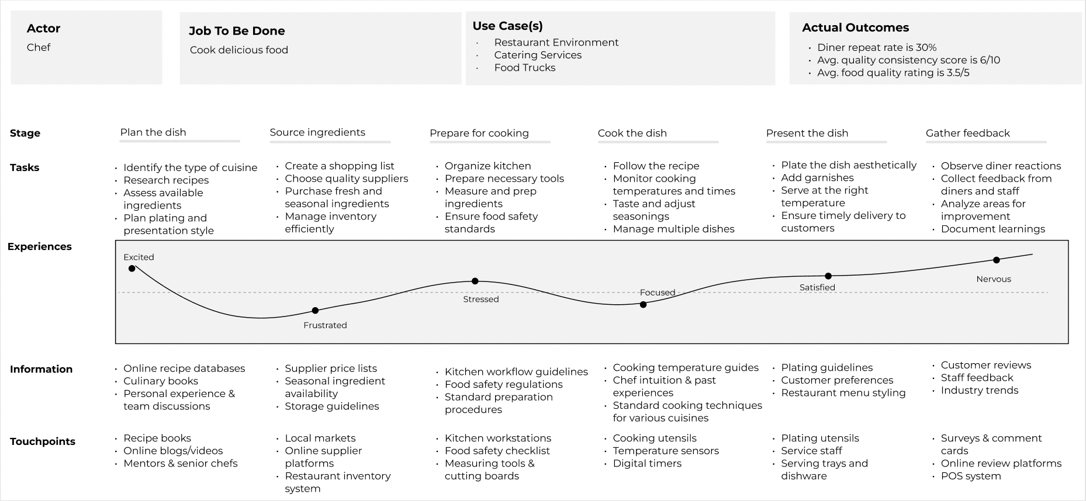

7. Use Cases

- Restaurant Environment
- Catering Services
- Food Trucks
- Private Chef Services
- Meal Prep Services

8. Problem Sizing

Average Diner Repeat Rate (Quarterly):
- 30% of customers return to the restaurant each quarter
Average Spend per Diner:
- $50 per visit (average spend per diner in the U.S.)
Number of Diners per Quarter per Restaurant:
- Average annual revenue for a restaurant is $1.76 million (assuming an average spend of $50 per diner).
- This results in about 35,306 diners annually
- Quarterly Diners: 35,306 ÷ 4 ≈ 8,827 diners per quarter.

Per Instance Calculation

- Gap per Instance (Per Diner Visit):
  - Desired Repeat Rate (Quarterly): 70%
  - Actual Repeat Rate (Quarterly): 30%
  - Gap: 70% - 30% = 40%
  - This means the restaurant is losing 40% of repeat diner visits each quarter.

Annualized per Actor (Per Restaurant)

- Number of Diners per Quarter (per Restaurant): 8,827 diners per quarter×4 quarters=35,308 diners annually per restaurant
- Desired Repeat Diners per Year (Desired Outcome): 35,308 diners annually×70%=24,715
- Current Repeat Diners per Year (Actual Outcome): 35,308 diners annually×30% = 10,592
- Lost Repeat Diners Annually (Gap Calculation): 24,715 repeat diners−10,592 repeat diners = 14,123
- Lost Revenue Annually per Restaurant: 14,123 lost repeat diners annually×50 dollars per diner= $706,150

Annualized per Actor (For All Chefs)

Now, let’s assume 100,000 chefs working across restaurants, as per industry estimates.
- Total Lost Revenue for All Chefs (All Restaurants):
$ 706,150 ×100,000 =70,615,000,000
Total Lost Revenue: $70.615 billion annually for all chefs due to the shortfall in repeat diner visits.

9. Problem Category

Customer Retention Problem

10. Problem Statement

The current diner repeat rate is 40% below the target of 70%, leading to an estimated annual revenue loss of $70.615 billion across 100,000 restaurants. This shortfall is primarily driven by ineffective customer retention strategies, resulting in low diner loyalty, decreased lifetime value, and reduced profitability for restaurants. Addressing this issue requires a data-driven approach to enhance diner experience, optimize engagement strategies, and improve retention rates.

2. Market Space

1. Overall Market

Market Name: Global Professional Chef Market
- Estimated Market Size: 15 million chefs worldwide (based on industry reports and employment statistics).
- Trends:
  - The demand for chefs is growing steadily due to the expansion of restaurants, food delivery services, and gourmet dining trends.
  - The rise of specialized diets (vegan, keto, gluten-free) has created opportunities for niche chefs.
  - The adoption of smart kitchen technology is reshaping how chefs work, with AI-driven appliances and automation.
- Source: Bureau of Labor Statistics, Statista, World Chef Association Reports.

2. Total Addressable Market (TAM)

DineIQ is targeted at full-service restaurants, fast-casual chains, and fine dining establishments that require chef-driven meal personalization. This excludes fast-food chains that rely on fixed menus and do not require AI-driven personalization.
Based on industry reports, the estimated number of full-service restaurants globally is 8 million.

TAM (Units Sold) = 8 million restaurants
Assumption: We estimate that 20% of these restaurants would be early adopters of AI-powered meal personalization, defining our Serviceable Addressable Market (SAM) as 1.6 million restaurants.
SAM (Units Sold) = 1.6 million restaurants (20% of TAM)

TAM Revenue Estimation

DineIQ operates under a tiered pricing model, offering three subscription plans:

Plan | Avg. Price per Month | Assumed Market Share
Basic | $99 | 30%
Standard | $249 | 50%
Premium | $399 | 20%

Weighted Average Subscription Price Calculation:
(99×0.30)+(249×0.50)+(399×0.20)=29.7+124.5+79.8=$234/month(99×0.30)+(249×0.50)+(399×0.20)=29.7+124.5+79.8=$234/month
Assumption: The average price per restaurant is $234 per month.

TAM (Monetary Size) Calculation:
8,000,000 restaurants×234×12=22.5 billion USD annually8,000,000 restaurants×234×12=22.5
billion USD annually
TAM (Revenue Potential) = ~$22.5 billion per year
SAM (Monetary Size) Calculation (20% of TAM):
1,600,000 restaurants×234×12=4.5 billion USD annually1,600,000 restaurants×234×12=4.5 billion USD annually
SAM (Revenue Potential) = ~$4.5 billion per year

Assumptions
- 100% market adoption for TAM, but 20% (1.6M units) for SAM as realistic serviceable demand.
- Weighted average subscription price ($234/month) based on tiered adoption.
- No additional costs factored in (e.g., add-ons, enterprise deals, discounts).

3. Market Segmentation

Variables | Values
Work Environment | Restaurant, Catering, Food Truck, Private Chef, Cloud Kitchen
Cuisine Expertise | Italian, French, Japanese, Indian, Vegan, Pastry
Experience Level | Beginner, Intermediate, Expert, Michelin-starred
Specialty | Fine Dining, Fast Casual, Bakery/Pastry, Fusion Cuisine
 | Traditional Cooking, Partially Automated, Smart Kitchen Integration
  Technology Adoption

4. Target Market Profiles

Segment 1: Fine Dining Executive Chefs
- Work Environment: Restaurants, Luxury Hotels
- Cuisine Expertise: French, Italian, Japanese
- Experience Level: Michelin-starred, Highly Experienced
- Technology Adoption: Low – relies on traditional techniques
- No. of Actors: Estimated 1.2 million chefs worldwide
- Growth Rate: Steady – Demand remains high in luxury markets
Segment 2: Smart Kitchen Chefs
- Work Environment: Cloud Kitchens, High-Tech Restaurants
- Cuisine Expertise: Multi-cuisine, Fusion, Health-based Foods
- Experience Level: Intermediate to Expert
- Technology Adoption: High – Uses AI-driven cooking assistants & automated prep stations
- No. of Actors: Estimated 2.5 million chefs
- Growth Rate: Growing fast – Driven by food tech advancements

Segment 3: Niche Specialty Chefs (Vegan, Keto, Gluten-Free)
- Work Environment: Specialized Restaurants, Private Chef Services
- Cuisine Expertise: Plant-based, Gluten-free, Keto-focused meals
- Experience Level: Beginner to Expert
- Technology Adoption: Moderate – Uses digital recipe platforms & nutrition tracking tools
- No. of Actors: Estimated 1.8 million chefs
- Growth Rate: Rapid growth – Driven by health-conscious consumers

5. Competition

Direct Competitors (Other Chefs or Culinary Services)

- Michelin-Starred Restaurants – Elite chefs competing at the highest level.
- Cloud Kitchens (Ghost Kitchens) – Businesses using optimized food prep & delivery.
- Meal Kit Services (e.g., HelloFresh, Blue Apron) – Offering consumers pre-portioned ingredients for chef-level meals at home.

Indirect Competitors (Alternative Cooking Methods or Technologies)

- AI-Powered Cooking Assistants – Samsung Bot Chef, Suvie Smart Cooker (reducing reliance on professional chefs).
- Food Delivery Services – UberEats, DoorDash, Zomato (offering restaurant-style food without dining out).
- Home Cooking Apps & Tutorials – MasterClass (Gordon Ramsay), YouTube Cooking Channels (enabling people to cook gourmet meals themselves).

6. Positioning Analysis

- Current State Positioning Map

Evaluation Criteria Used by Chefs to Select Cooking Solutions:

    - Skill-Based Creativity – Measures the level of culinary artistry and personal creativity a chef can apply.
    - Automation – Evaluates the level of technological integration and reliance on automation
    - Accessibility & Cost – Assesses the affordability and availability of the solution.
    - Efficiency & Scalability – Determines how well the solution supports high-volume production without compromising quality.

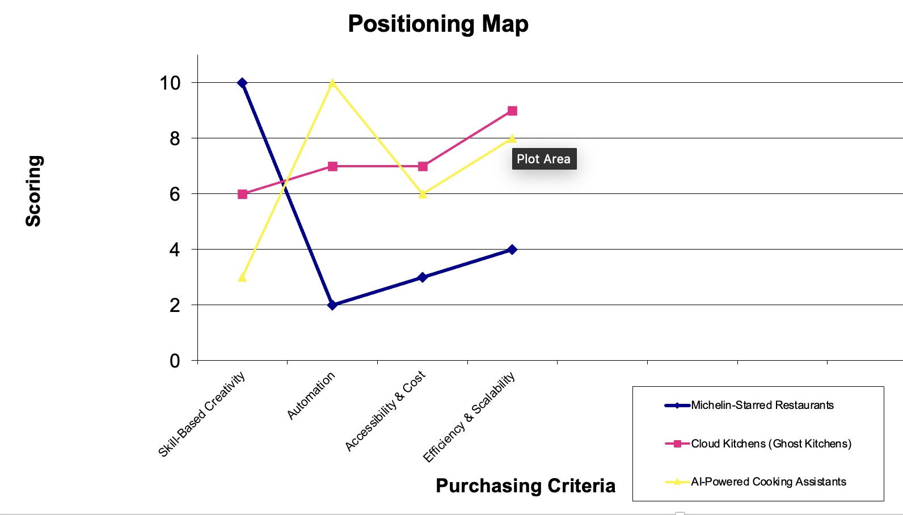

- Future State Positioning Map

Proposed New Evaluation Criterion: Diner Engagement & Retention

This criterion measures how well a cooking solution enhances diner engagement and increases repeat visits. It focuses on long-term customer loyalty and personalized experiences.

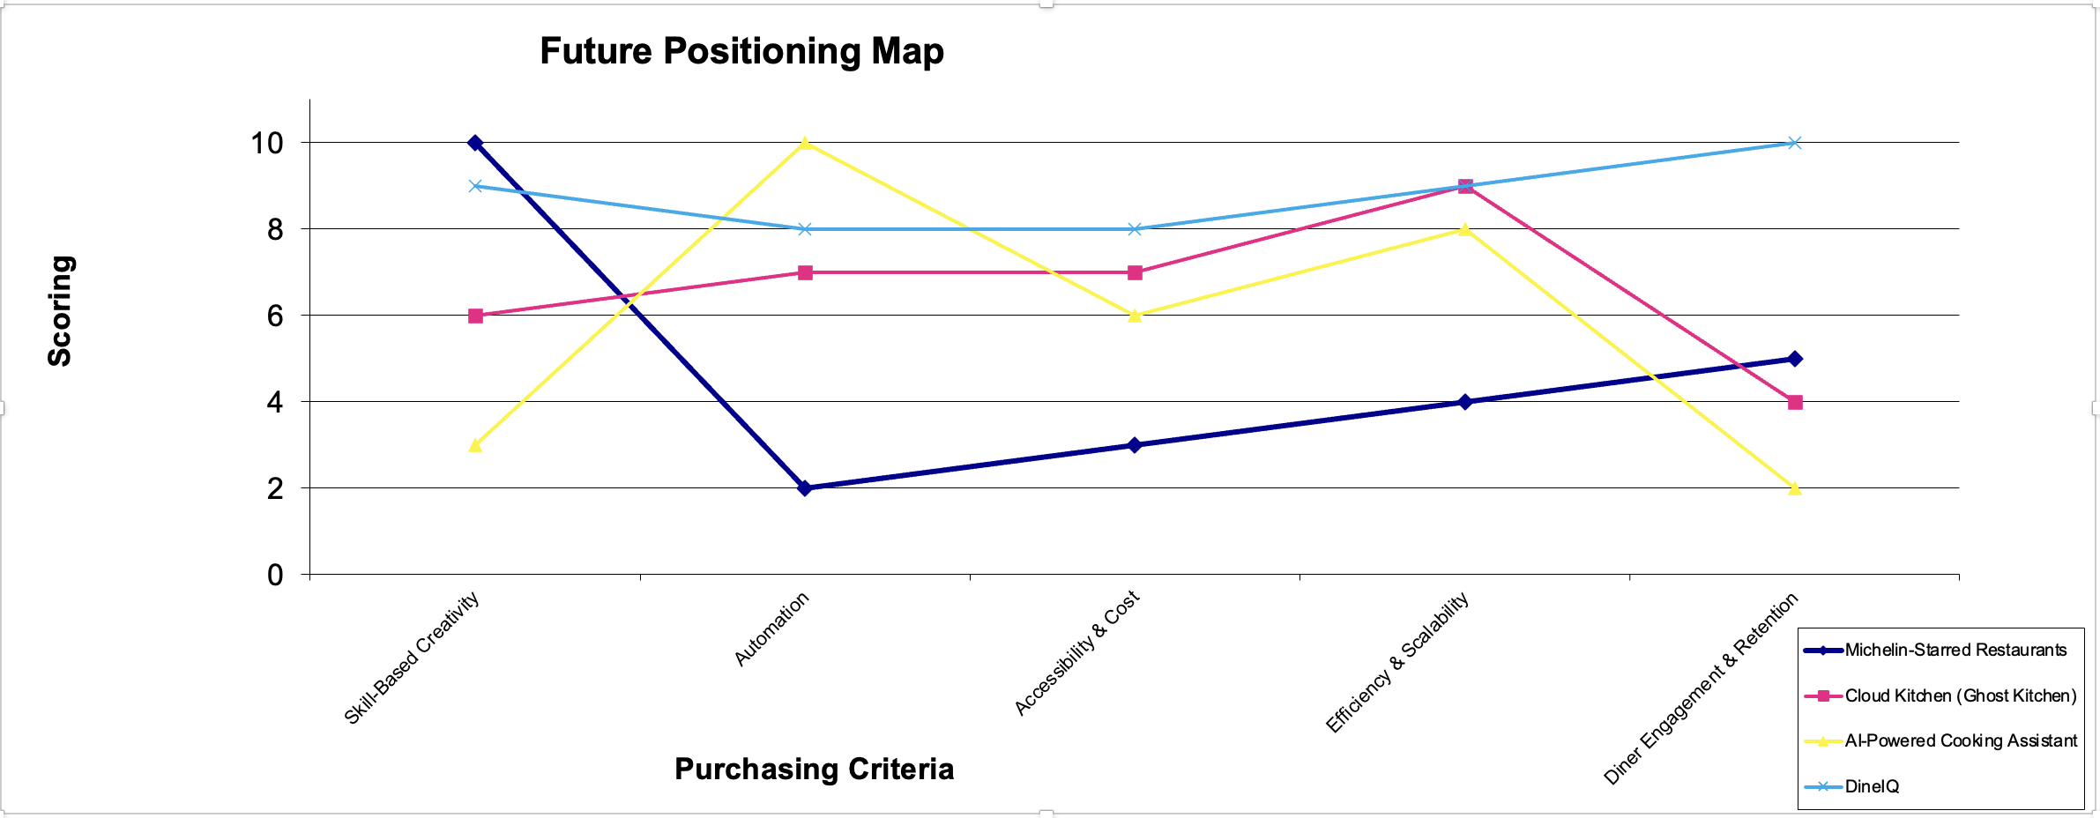

Justification for Positions-to-Own:
The AI-Generated Personalization for Diners (DineIQ) is a smart, AI-driven system that enhances diner engagement, improves repeat rates, and refines food quality through personalized experiences. Unlike traditional restaurant models or fully automated AI cooking assistants, DineIQ analyzes diner preferences, past orders, and real-time feedback to recommend customized dishes, ingredient modifications, and flavor optimizations. This ensures that each dining experience is unique, engaging, and tailored to customer tastes, increasing loyalty and overall satisfaction. It helps in empowering the chef rather than replacing.

Evaluation Criteria | DineIQ Rating | Reasoning for the Rating
Skill-Based Creativity | 9/10 | Unlike full automation, DineIQ enhances, rather than replaces, chef creativity. Chefs still have control over dishes, but AI suggests optimizations based on diner data.
Automation | 8/10 | DineIQ integrates AI-driven insights but does not fully automate the cooking process. It assists chefs in decision-making but leaves execution in human hands.
Accessibility & Cost | 8/10 | DineIQ is affordable and integrates seamlessly into existing restaurant operations. Unlike Michelin-starred kitchens (high cost) or AI cooking bots (complex setup), it works with existing infrastructure.
Efficiency & Scalability | 9/10 | DineIQ enhances efficiency by automating diner personalization, optimizing menu performance, and streamlining kitchen workflows. Reduces manual decision-making, improves order accuracy, and scaling without additional labor costs
Diner Engagement & Retention | 10/10 | Unlike other competitors, DineIQ is the only solution that actively enhances diner engagement through AI-powered personalization, increasing repeat visits and long-term loyalty.

- Position-to-Own

For chefs in full-service restaurants and cloud kitchens looking to enhance diner engagement and improve meal personalization, DineIQ is an AI-driven culinary assistant that analyzes diner preferences, past orders, and real-time feedback to help chefs craft tailored dining experiences. Unlike AI-powered cooking assistants that replace chef decision-making or cloud kitchens that prioritize efficiency over personalization, DineIQ enhances creativity while optimizing kitchen workflows, thus allowing chefs to deliver high-quality, personalized meals efficiently and at scale. By automating diner personalization, refining menu recommendations, and improving order accuracy, DineIQ helps chefs increase customer retention, improve food quality ratings, and differentiate their culinary offerings, without increasing kitchen complexity or labour costs.

7. Market Focus Decision

Target Market:

Professional chefs in full-service restaurants and cloud kitchens who want to increase diner retention, improve food quality consistency, and personalize meals efficiently while maintaining creative control.

Market Need & Justification:

- Chefs struggle with diner retention because traditional restaurant models lack scalable personalization, leading to low repeat visits and inconsistent engagement.
- Existing solutions (AI-powered cooking assistants & cloud kitchens) prioritize efficiency and automation but do not empower chefs to create tailored dining experiences for customers.
- DineIQ fills this gap by offering an AI-powered tool that helps chefs dynamically adjust dishes based on diner preferences, streamline decision-making, and enhance engagement, without increasing kitchen complexity.

Reasons to choose this market:

- High-Impact Pain Point: Diner retention is a major challenge in both full-service restaurants and cloud kitchens. By improving personalization, DineIQ directly drives repeat visits, higher food quality ratings, and greater customer satisfaction.
- Scalable Across Segments: Works for both fine-dining and fast-casual chefs, allowing luxury restaurants to refine guest experiences while helping cloud kitchens introduce personalization into standardized meals.
- Competitive Differentiation: Unlike Michelin-starred restaurants that rely on exclusivity or AI-powered cooking assistants that automate the chef’s role, DineIQ enhances, rather than replaces, the chef’s expertise, thus giving them intelligent meal personalization tools that increase efficiency while maintaining culinary creativity.

3. Solution Space

1. Product Focus Decision

Product Name :

DineIQ

Purpose (What Problem It Solves) :

DineIQ helps chefs personalize dishes in real-time by leveraging AI-driven insights based on diner preferences, past orders, and feedback. This enhances diner engagement, improves food quality consistency, and increases repeat visits without compromising chef creativity.

Product Category :

AI-Powered Culinary Assistant

Main Attributes (Key Features & Functionalities) :

- AI-Powered Flavor Optimization & Consistency Control – Ensures taste consistency by providing real-time seasoning and ingredient adjustments based on diner preferences.
- Dynamic Menu Insights & Dish Performance Analytics – Tracks dish popularity, customer sentiment, and suggests modifications for underperforming menu items.
- Smart Kitchen Workflow Integration – Syncs with kitchen displays and POS systems to streamline diner-specific customization requests.
- Personalized Dish Recommendations – Suggests custom modifications based on dietary history, spice tolerance, and past orders.
- Chef’s Surprise & Discovery Mode – Allows chefs to craft personalized dishes while offering diners an exploratory "surprise me" feature.
- AI-Powered Loyalty & Smart Promotions – Identifies frequent diners and offers personalized rewards, exclusive tasting menus, and VIP experiences.

Properties (Form & Format) :

- Software-Based Solution : Web and tablet-compatible chef dashboard.
- Cloud-Integrated : Syncs across multiple restaurant locations.
- Modular AI Engine : Can be customized for different cuisine types and kitchen workflows.

Key Technology Used :

- AI & Machine Learning Algorithms – For diner preference modeling and meal customization.
- Natural Language Processing (NLP) – To analyze written feedback from diners.
- Predictive Analytics – To suggest menu optimizations based on sales data and ratings.
Operating Requirements :

- Compatible with iOS, Android, and Web browsers.
- Requires restaurant POS system integration (Square, Toast, Lightspeed, etc.)
- Internet connectivity needed for real-time AI recommendations.

How It Works :

1️. Chef logs into DineIQ and reviews AI-generated meal suggestions based on diner preferences.
2. Chef customizes dish recommendations by accepting, modifying, or ignoring AI suggestions.
3. Finalized meals are added to "Today's Menu," making them available for orders.
4. Chef tracks incoming orders in real-time, with diner names and AI-suggested customizations.
5. Chef accesses full recipes for modified dishes through a Modify Recipe link available .
6. Orders progress through stages (Pending → In Progress → Completed), updated manually or automatically.
7. DineIQ collects diner feedback and refines future meal recommendations based on ratings and preferences.

2. User Views
2. Chef will plan today’s menu from the AI generated meal-suggestions
1. Chef login
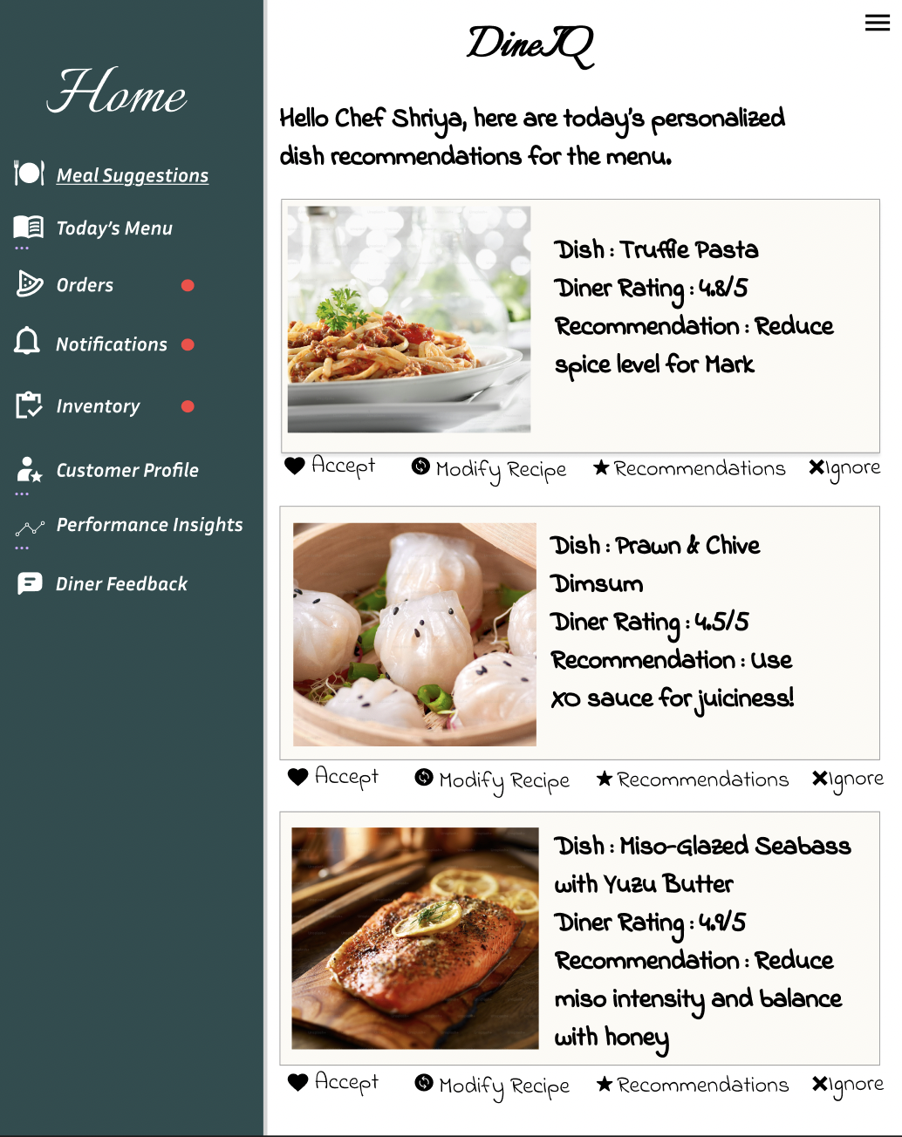
4. Diner feedback is collected for future AI ooptimization
5. Chef checks customer profiles for recipe customizations.
4. Chef tracks active orders, progress and meal adjustments
3. Chef can accept the suggestion, modify recipe, look for more AI recommendations for that recipe(ingredient alternatives, drink pairings), or ignore that recipe.

3. Functional Requirements

1. Personalized Meal Suggestions
- Requirement ID: FR-001
As a chef, I need AI-generated meal suggestions based on past diner preferences so that I can customize dishes and improve diner retention.
- Requirement ID: FR-002
As a chef, I want to view AI recommendations for each dish, including spice level adjustments and ingredient swaps, so that I can ensure consistency and personalization.

2. Order Tracking & Customization
- Requirement ID: FR-003
As a chef, I need to see a real-time list of orders with diner names and preferences so that I can personalize meals efficiently.
- Requirement ID: FR-004
When a new order is placed, I want to receive immediate alerts for customization requests, so I can adjust the dish before preparation begins.
- Requirement ID: FR-005
As a chef, I want to access a linked recipe for each customized dish so that I can quickly reference adjustments needed for individual diner preferences.

3. Diner Feedback & Ratings
- Requirement ID: FR-006
As a chef, I need to see diner ratings and feedback on past meals so that I can continuously refine dish quality and personalization.
- Requirement ID: FR-007
When a diner provides negative feedback, I want AI-powered suggestions for improvement so that I can take immediate corrective action.

4. Performance Insights & Reporting
- Requirement ID: FR-008
As a chef, I want to track diner repeat rate and dish popularity over time so that I can refine my menu offerings.
- Requirement ID: FR-009
As a chef, I need AI-driven reports on the most and least popular dishes so that I can make data-driven decisions on menu updates.

5. Inventory Management Integration
- Requirement ID: FR-010
As a chef, I need real-time ingredient availability updates so that I can avoid suggesting dishes that cannot be prepared.
- Requirement ID: FR-011
When a dish modification is suggested, I want AI to check ingredient availability automatically so that I can ensure feasibility before confirming changes.

- Context View

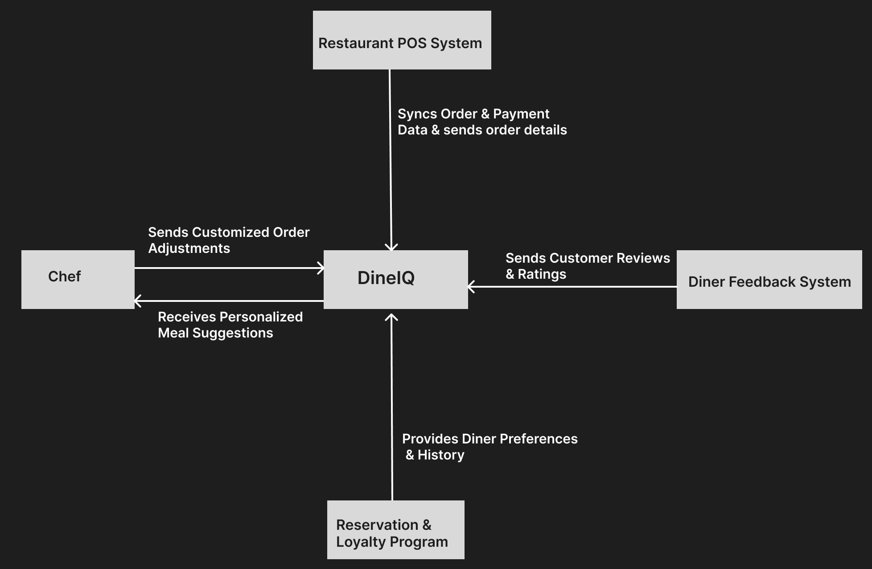

5. Non-Functional Requirements

ID | Category | Requirement Statement
NFR-01 | Interoperability | DineIQ must integrate with major POS (Point-of-Sale) systems and reservation platforms to pull diner preferences and order history in real time.
NFR-01 | Compatibility | The system must be accessible via web browsers (Chrome, Safari, Edge) and mobile devices (iOS, Android) without loss of functionality.
NFR-01 | Responsiveness | DineIQ must provide AI-generated meal modification suggestions within 2 seconds of receiving an order.
NFR-01 | Usability | The interface must allow chefs to modify a recipe with no more than 3 clicks.
NFR-01 | Availability | The system must have a 99.9% uptime SLA to ensure uninterrupted access during restaurant operating hours.
NFR-01 | Accuracy | AI-generated recommendations must reflect at least 90% of diner preferences based on historical data and explicit feedback.
NFR-01 | Security | DineIQ must encrypt all customer and order data using AES-256 encryption to prevent unauthorized access.
NFR-01 | Privacy | Personal diner information must not be stored beyond 6 months and must comply with GDPR & CCPA regulations.
NFR-01 | Safety | The system must provide real-time alerts for ingredient-related allergens and dietary restrictions to prevent accidental exposure.

4. Customer Value Space

1. Product Features and Benefits

Product Feature | Benefits
AI-Powered Meal Personalization | Helps chefs customize dishes based on diner history, leading to higher customer satisfaction and retention
Customizable Recipe Modifications | Chefs can tweak AI-generated suggestions for each dish, allowing flexibility while maintaining efficiency.
Diner Feedback Integration | Captures real-time diner ratings and reviews, helping chefs refine their dishes and improve quality consistency
Order Progress & Tracking | Provides a structured order management system, ensuring smoother kitchen workflow and reducing errors.
Ingredient & Allergen Alerts | Notifies chefs about dietary restrictions and allergen risks, improving food safety and customer trust.
Performance Insights Dashboard | Allows chefs to analyze trends in diner preferences and make data-driven menu adjustments.

2. Customer Value Proposition Strategy

Chosen Strategy: More for the Same
DineIQ provides AI-driven personalized meal recommendations that enhance diner experience, increase customer retention, and improve chef efficiency, thus offering more benefits without increasing costs compared to traditional menu planning tools.
Justification:
- Chef Productivity: Helps chefs efficiently customize meals without additional workload.
- Diner Satisfaction: Personalized meal recommendations increase diner loyalty and return rates.
- No Additional Cost Burden: Unlike expensive AI-driven kitchen automation, DineIQ integrates with existing restaurant systems at a competitive price.
Pricing Support: The pricing model ensures that restaurants can adopt this tool without significantly increasing costs, making it a sustainable investment for long-term diner engagement and efficiency.

3. Pricing Model

- Price Setting Strategy: Segmented Pricing (Tiered Model)
- Basic: Limited AI recommendations, suitable for small restaurants.
- Standard: Full personalization features and analytics for mid-sized restaurants.
- Premium: Advanced predictive analytics, API integrations, and automation support for high-end restaurants.

- Pricing Metrics:
- Per Active Chef User per Month
- Per Number of Unique Diners Engaged
- Per Restaurant Location

- Payment Structure:
- Items Priced: Subscription per restaurant location
- Frequency: Monthly billing cycle
- Timing: Payments processed at the beginning of each month
- Source: Auto-payment through credit/debit cards or restaurant POS integration

- Price:
- Basic Plan: $99/month
- Standard Plan: $249/month
- Premium Plan: $399/month

Justification:

- The pricing model aligns with customer benefits, restaurants with higher usage pay more.
- Subscription pricing ensures steady revenue while keeping the product affordable for different restaurant types.
- Pricing tiers allow accessibility for small restaurants while offering premium features for larger establishments.
- Basic Plan: Designed for small restaurants with limited budgets, allowing them to experience AI-driven personalization at an affordable entry point. Competitively priced against lower-end POS solutions.
- Standard Plan: Provides full AI-driven meal personalization & analytics, priced to reflect real diner engagement impact. Competitive with other AI-powered restaurant analytics tools.

- Premium Plan: Includes advanced automation, predictive analytics, and multi-location AI insights, priced below enterprise AI competitors while offering superior capabilities.

- Customer Cost Items

Cost Item | Description | Quantifiable | Estimated Cost
DineIQ Subscription Fee | Monthly fee based on plan (Basic: $99, Standard: $249, Premium: $399) | Yes | $99 - $399/month
Integration Cost (One-time setup) | POS system & reservation system integration (if required) | Yes | $200 (one-time)
Possible Hardware Upgrade | If the restaurant lacks compatible tablets/computers | Yes | $500 - $1,500 (if required)
Ongoing Support & Updates | Regular feature updates, AI improvements, customer support | Yes | Included

- Customer Value Proposition Evaluation

Will Customers Find This Compelling?
- ROI-Driven: AI-driven personalization improves diner retention & increases revenue
- Operational Efficiency: Reduces chef workload and streamlines menu planning.
- Affordable & Scalable: Flexible pricing ensures accessibility for small & large restaurants.
- Competitive Differentiation: AI-powered menu planning enhances restaurant offerings.

How Restaurants Can Justify Acquiring DineIQ
- Increased Revenue: A 20% boost in repeat diners significantly increases restaurant income.
- Time Savings: AI reduces manual menu adjustments, saving chefs hours per week.
- Predictable Pricing: Flat fees & no surprise charges make budgeting simple.

Appendix

[items included here, as needed, with the details to complement or support the above work.]

[1] Restaurant Website Builder. "Average Diner Repeat Rate (Quarterly)." Accessed February 1, 2025. https://www.restaurantwebsitebuilder.com/average-diner-repeat-rate.
[2] Escoffier. "Consumer Dining Trends: How Americans Are Spending on Dining Out." Last modified October 2024. Accessed February 1, 2025. https://www.escoffier.edu/blog/world-food-drink/consumer-dining-trend-statistics/.
[3] Lineup.ai. "What is the Average Restaurant Revenue?" Accessed February 1, 2025. https://lineup.ai/average-restaurant-revenue/.

